
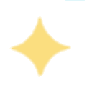


DEEP CLEANING






IN ALL ROOM
- A full sanitation
- Baseboards hand cleaned
- Blinds & windowsills detailed clean
- Door frames, doors & trim dusted & cleaned (as needed)
- Cabinets interior hand wiped within reach (only if empty)
- Oven interior cleaned
- Ceiling fans dusted & cleaned
- High ceilings dusted (cleaners will not use ladders)
- Air vents dusted
- Top of refrigerator wiped & interior detail clean (If it’s stocked, may not be fully cleaned)
- Showers detail clean & scrubbed
- Toilets scrub hard water rings
- Floors detail mopped & scrubbed (as needed)
- Note: wall washing is NOT included

BADROOMS
- Beds are made
- Sheets are washed

BATHROOMS

- Shower fully cleaned inside & out
- Toilet cleaned/sanitized inside & out
- Sink & Handles cleaned/sanitized
- Countertop cleaned/sanitized
- Mirrors cleaned
- Towels folded & replaced
- Cabinets exterior cleaned (as needed)

KITCHEN

- Countertop cleaned/sanitized
- Appliance exteriors cleaned
- Microwave & fridge cleaned inside
- Dishwasher emptied upon completed cycle
- Overhead fan cleaned
- Sink & handles cleaned/sanitized
- Kitchen table & chairs cleaned
- Cabinets exterior cleaned (as needed)

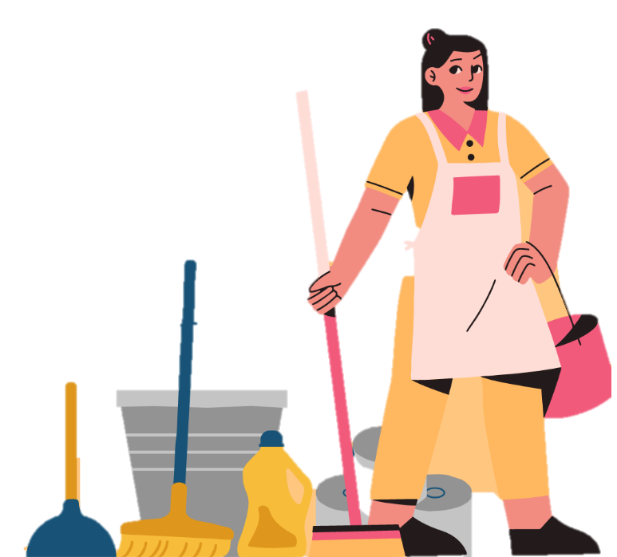

v
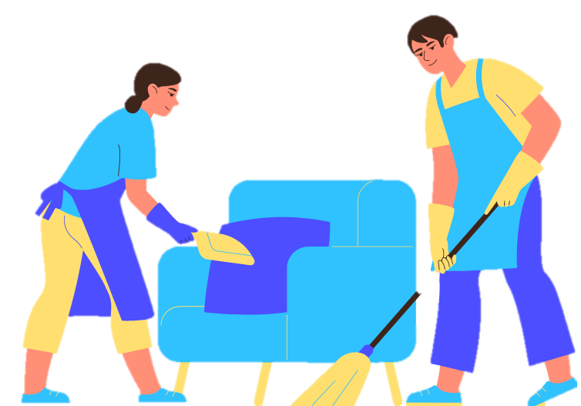
All

- Organize items & furniture (as needed)
- Trash emptied & removed, bag replaced
- Baseboards hand cleaned
- Blinds & windowsills detailed clean
- Cobwebs removed from reachable surfaces
- Door frames, doors & trim dusted & cleaned (as needed)
- Ceiling fans dusted & cleaned
- Air vents dusted
- All floors & stairs vacuumed & cleaned & mopped
- Hangings on walls & mirrors cleaned
- Sliding glass doors & windows spot cleaned (as needed)
- Light fixtures & lamp shades dusted
- Furniture dusted & cleaned (as needed)
- Fireplace ashes removed if cool & swept


