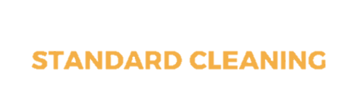

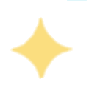






IN ALL ROOM

- Organize items & furniture (as needed)
- Trash emptied & removed, bag replaced
- Blinds & windowsills dusted
- Cobwebs Removed from Reachable Surfaces
- All floors & stairs vacuumed & mopped
- Hangings on walls & mirrors cleaned
- Sliding glass doors & windows spot cleaned (as needed)
- Light fixtures & lamp shades dusted
- Furniture dusted & cleaned (as needed)
- Fireplace ashes removed if cool & swept




BADROOMS
- Beds are made
- Sheets are washed


BATHROOMS

- Shower fully cleaned inside & out
- Toilet cleaned/sanitized inside & out
- Sink & Handles cleaned/sanitized
- Countertop cleaned/sanitized
- Mirrors cleaned
- Towels folded & replaced
- Cabinets exterior cleaned (as needed)

KITCHEN

- Countertop cleaned/sanitized
- Appliance exteriors cleaned
- Microwave & fridge cleaned inside
- Dishwasher emptied upon completed cycle
- Overhead fan cleaned
- Sink & handles cleaned/sanitized
- Kitchen table & chairs cleaned
- Cabinets exterior cleaned (as needed)



v

ADD ON’S TO
A STANDARD CLEANING
- Laundry washed, sheets & towels
- Oven interior cleaned
- Refrigerator detail cleaned
- Sweep garage, decks & organize outdoor furniture
- Scrub BBQ
- Cleaning garage or yard
- Light switches, doorknobs, door frames, TV, remotes, cabinet
- Drawer handles, counters, toilets, sinks, faucets, stair
- Railings

EXTRA SANITATION SERVICE

